NAME: ………………………………………………….

FOR EXERMINER ONLY:

|  |  |  |
| --- | --- | --- |
| A |  | TOTAL |
| B |  |  |

LEARNER’S IDENTIFICATION NUMBER: ………………………………….

**THE PHYSICS DEPARTMENT**

**END OF TERM II EXAMINATION**

**PHYSICS PAPER 1**

**SENIOR 3**

**2hrs**

**………………………………………………………………………………………**

**Instructions:**

* Section A has 10 questions each carrying 5 marks.
* Section B has four numbers each carrying 15 marks
* You are required to pick 2 numbers from section B.
* Neatness is a must (1 mark will be lost for any untidy work)
* Where necessary the following can be used.

Acceleration due to gravity = 10ms-2

………………………………………………………………………………………………….

**SECTION A**

1. On a construction company site, an effort of 50N is required to raise concrete of 200N using a pulley system of velocity ratio 5.
2. Draw a diagram to show the pulley system. $(01 marks)$

b). Find the efficiency of system. ${(2}_{2}^{1} marks)$

…………………………………………………………………………………………………………………………………………………………………………………………………………………………………………………………………………………………………………………………………………………………………………………………………………

c)(i). Is the efficiency less or greater than 100%? ${(0}_{2}^{1} marks)$

………………………………………………………………………………………………….

(ii) Give a reason for your answer in c(i) $(01marks)$

…………………………………………………………………………………………………………………………………………………………………………………………………..

1. Allan was on the balcony of their house and his smart phone accidentally fell on the ground.

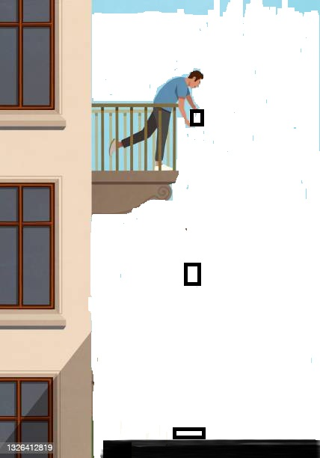

50m

1. (i) The law of conservation of energy denies loosing energy but instead it is transformed into other forms. On the above picture, mark **3** points showing clearly the energy transformations of the phone as it if falling from the hands to the ground. $(02 marks)$

(ii) Calculate the velocity with which Allan’s phone had immediately when it has just landed the ground. $(02 marks)$

…………………………………………………………………………………………………………………………………………………………………………………………………………………………………………………………………………………………………………………………………………………………………………………………………………………………………………………………………………………………………………………………………………………………………………………………………………………..

1. Energy transformation can only occur when there is a device which causes it. You are required to give at least **on** energy transformation with the corresponding device. $(01 marks)$

………………………………………………………………………………………………………………………………………………………………………………………………………………………………………………………………………........................

1. Below is a screw driver which was used by Abdul as he was fixing the nail in a car.

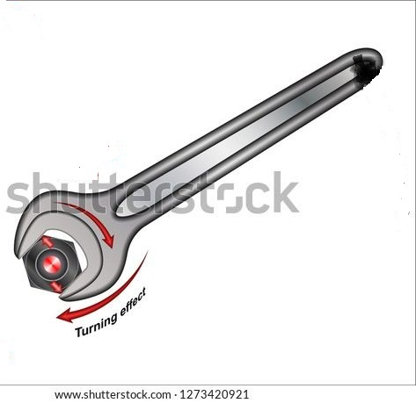

**X**

**Z**

He tried the screw at different points **X** and **Z.** At point **X** he was putting in a lot of effort than at **Z** when turning the screw.

1. Give a reason why there was a difference in the efforts he applied at the two points.

………………………………………………………………………………………………………………………………… $(02 marks)$……………………………………………………………………………………………………………………………………………………

1. If the length of the screw driver was $15cm$, and the turning effect caused was $0.3Nm$. What effort did Abdul apply in order to cause the effect? $(02 marks)$

…………………………………………………………………………………………………………………………………………………………………………………………………………………………………………………………………………………………………………………………………………………………………………………………………………………………………………………………………………………………………………………………………………………………………………………………………………………..

1. State what you think would happen if a young child used the screw while holding at point **Z. $(01 marks)$**

…………………………………………………………………………………………………………………………………………………………………………………………………………………………………………………………………………………………................

1. In a quest to compare the densities of two liquids, Cedric used the hare’s apparatus and the figure below shows the result.

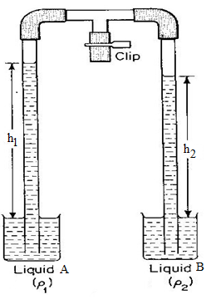

* 1. Of the two liquids which one is denser than the other?

……………………………………………………………………………………………………………………………………………………

* 1. Give a reason to support your answer.

………………………………………………………………………………………………………………………………………………………………………………………………………………………………………………………………………………………………………..

* 1. If the density of the liquid **B** is $1000kgm^{-3}$, what is the density of the liquid **A.?**

…………………………………………………………………………………………………………………………………………………………………………………………………………………………………………………………………………………………..………………………………………………………………………………………………………………………………………………………………………………………………………………………………………………………………………………………………….........

* 1. Give the significance of density in everyday life. $(01 marks)$

………………………………………………………………………………………………………………………………………………………………………………………………………………………………………………………………………………………...................

1. Below is a pin hole camera modeled by Immaculate to investigate a certain principle of light.

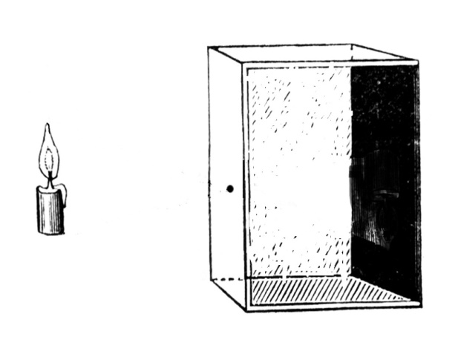

* 1. Indicate on the diagram above, how the image is formed. $(01 marks)$
  2. What are the properties of the internal surfaces of the pinhole camera? And why designed in that way.

……………………………………………………………………………………………………………………………………………………………………………………………………………………………………………………………………………………………………………………………………………………………………………………………………………………………………………………………..

* 1. Describe the Image formed.

………………………………………………………………………………………………………………………………………………………………………………………………………………………………………………………………………………………………………….

* 1. State the principle under investigation. $\left(01 marks\right)$

…………………………………………………………………………………………………………………………………………………………………………………………………………………………………………………………………………………………………………

1. The figure below shows a lamp. Akello lighted it but got into questions to what enables it to give out light. You are required to answer the questions that follow.

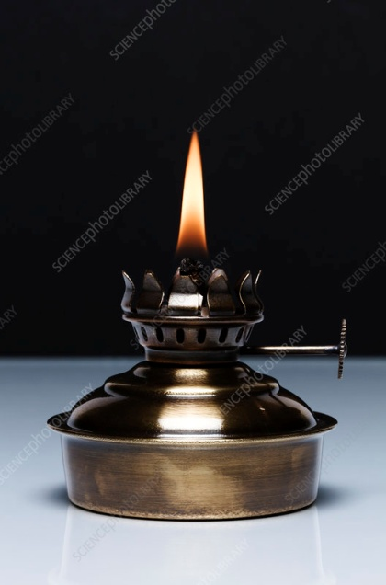

* 1. Give a reason to why fuel was able to move up the wick besides it not being sucked by the user.

…………………………………………………………………………………………………………………………………………………………………………………………………………………………………………………………………………………………………………

* 1. Below are two capillary tubes of the same size dipped in a container having water and mercury respectively

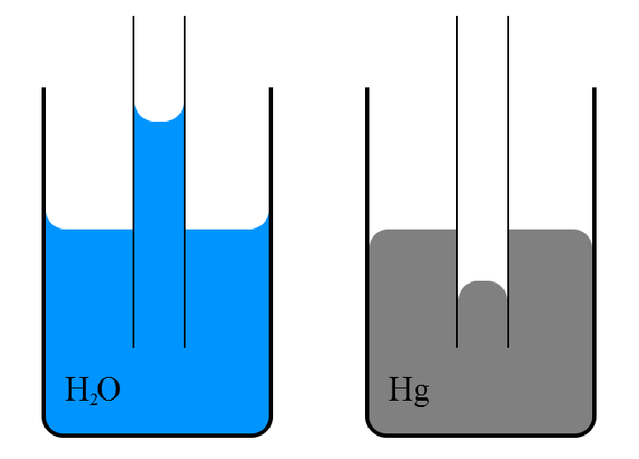

1. What is the difference between what is observed? $(01 marks)$

………………………………………………………………………………………………………………………………………………………………………………………………………………………………………………………………………………………………………....

1. Explain why there is that difference.

……………………………………………………………………………………………………………………………………………………………………………………………………………………………………………………………………………………………………......

* 1. Give any other application of the above concept in real life. $(01 marks)$

…………………………………………………………………………………………………………………………………………………………………………………………………………………………………………………………………………………………………………

1. Urban was to buy a gold watch worthy $₤200$ from Travour. But he is worried because of the bad rumors which have been moving around the town about the watches sold by Travour. I.e. they are not of pure gold. The friend is convincing him that the watch is pure gold.
2. In brief, how can Urban avoid being cheated? $(02 marks)$

…………………………………………………………………………………………………………………………………………………………………………………………………………………………………………………………………………………………………………

1. If the mass of the watch is $386g$ and the volume ${20cm}^{3}$, what is the density of the watch in $kgm^{-3}$. $\left(2\frac{1}{2} marks\right)$

…………………………………………………………………………………………………………………………………………………………………………………………………………………………………………………………………………………………………………………………………………………………………………………………………………………………………………………………………………………………………………………………………………………………………………………………………………………….

1. Below is a racing car moving at an acceleration of $0.02{ms}^{-2}$ around a corner.

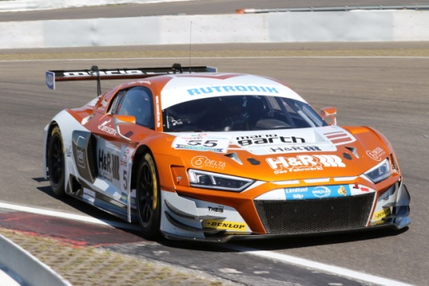

1. What is the meaning of acceleration? $(01 marks)$

…………………………………………………………………………………………………………………………………………………………………………………………………………………………………………………………………………………………………………

1. If the racing car started moving with a velocity of $10{ms}^{-1}$ and at the finishing line it had $100{ms}^{-1}$. How long did it take to reach the finishing line? $(02 marks)$

………………………………………………………………………………………………………………………………………………………………………………………………………………………………………………………………………………………………………………………………………………………………………………………………………………………………………………................

1. How far is the starting point from the finishing line? $(02 marks)$

………………………………………………………………………………………………………………………………………………………………………………………………………………………………………………………………………………………………………………………………………………………………………………………………………………………………………………………………

1. A vehicle designed for carrying heavy loads across mud has four wide low pressure Tyres, each of which is 120cm wide. When the vehicle and its load are combined the mass is 12000kg and each Tyre flattens so that 50cm of the Tyre is in contact with the mud as shown in the diagram below.



1. Give a reason to why its made with low pressure Tyres. $(01 marks)$

…………………………………………………………………………………………………………………………………………………………………………………………………………………………………………………………………………………………………………

1. What is the total pressure exerted by the vehicle on the mud? $(04 marks)$

…………………………………………………………………………………………………………………………………………………………………………………………………………………………………………………………………………………………………………………………………………………………………………………………………………………………………………………………………………………………………………………………………………………………………………………………………………………...

1. An astronaut moved to the moon from the earth. Below is a picture showing the astronaut on moon.

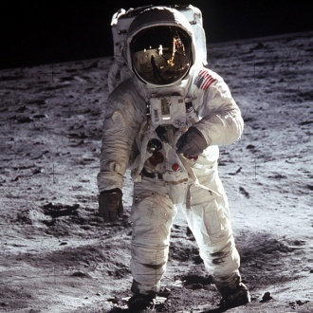

When he was on the moon, he felt a reduction in how heavy he was while on earth that is his weight was less than that when on moon.

1. Give a reason why there was a difference. $(02marks)$

…………………………………………………………………………………………………………………………………………………………………………………………………………………………………………………………………………………………………………

1. If the acceleration due to gravity on moon is $1.67{ms}^{-2}$ and on earth he was weighing $450N$, what was the astronaut’s weight while on the moon? $(02 marks)$

……………………………………………………………………………………………………………………………………………………………………………………………………………………………………………………………………………………………………………………………………………………………………………………………………………………………………………………………………………………………………………………………………………………………………………………………………………………

1. Give two differences between mass and the weight of an astronaut. $(01marks)$

…………………………………………………………………………………………………………………………………………………………………………………………………………………………………………………………………………………………………………

**SECTION B**

1. The figure below shows two different kinds of animals. The two animals were in mud but it was noticed that one of the animal was facing challenges in walking.

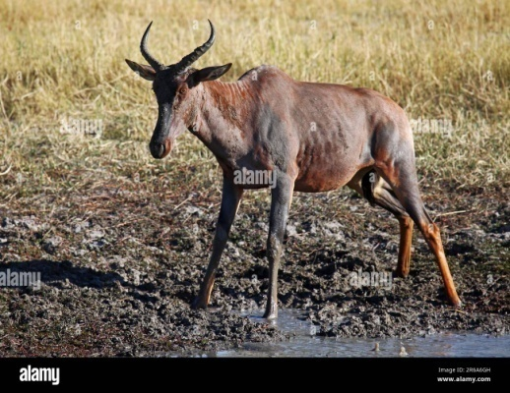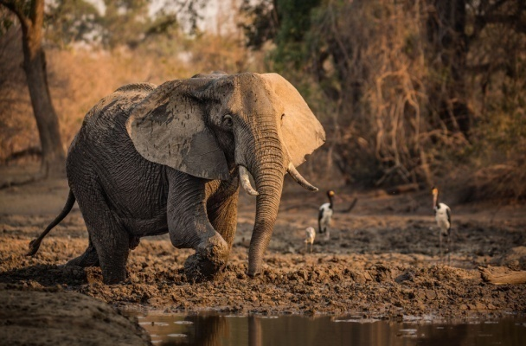

* 1. (i) With a reason, state the animal that can easily walk in areas full of mud. $(03 marks)$

1. Given that the elephant has of mass 4000kg and its foot has an area of $275{cm}^{2}$ find the pressure the elephant exerts on the ground. $(3marks)$
   1. Below is a hydraulic brake (car brake) you are required to study it and answer the questions that follow.

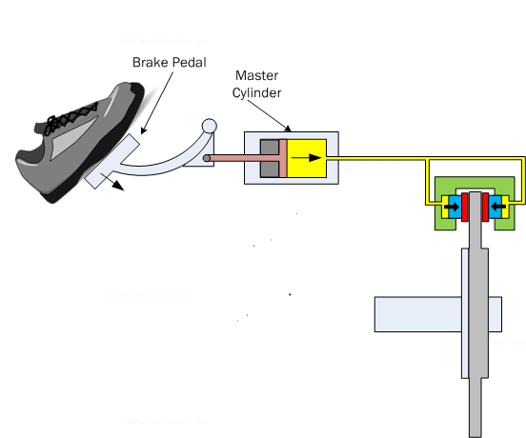

Piston on the brakes

Brake fluid

Main piston

1. Which principle do the car brake works? $(01marks)$
2. How do the principle state?
3. Briefly describe how it works using the principle you have stated $(04 marks)$
4. State any two properties of the liquid used in the car brake. $(01 marks)$
5. The above car brake system is designed with the following properties: the area of the main piston is $7.20 × {10}^{-4}m^{2}$, the area of the piston in each individual brake system is $1.80 × {10}^{-4}m^{2}$. If the driver exerts a force of $6.00N$, Find the force that makes the tyres to stop moving. (03 marks)
6. (a) Its known that a person can move **too freely** in air, **freely** in liquid but finds hardships and **impossible** to pass through a solid. Using your knowledge to the states of matter, explain why that happens. $(05 marks)$

(b) Faisal constructed the latrine for his tenants but People from the neighborhood are complaining about the bad smell from the latrine.

1. Why do you think people who are not inside or near the latrine are getting the smell? $(01 marks)$
2. People also reported that on cold days the situation is worse than on hot days. They are wondering why this is so. Give a reason why this is like that. $(04 marks)$
3. Which advice do you give to Mr. Faisal? $(03 marks)$
4. Give two advantage of the above mechanism that makes the smell of the latrine to be in the neighborhood in rest life? $(02 marks)$
5. (a) Pieces of pure ice at temperature of $-5℃$ were placed in a container containing water and heated to a temperature of $8℃$.
6. Sketch a graph of change volume of water against Temperature. $(02 marks)$
7. Explain the shape of your graph $(02 marks)$
8. What does the shape of the graph between $0℃$ to $4℃$ show and how is it important? $(02 marks)$

(b) Below is mercury in glass thermometer used in the Bright future school clinic.

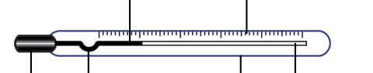

1. In brief, if you were the nurse in the hospital, how could you use the above thermometer?

$(02 marks)$

1. Which thermometric property does the above thermometer use? $(01 marks)$
2. If water was used instead of mercury, give at least two success and failure you will get while using the thermometer $(02 marks)$
3. Before the thermometer is calibrated to measure temperature accurately, it is first used when it’s uncalibrated. Winnie was using uncalibrated thermometer to measure the temperature of his brother and the following are the results she got.

|  |  |
| --- | --- |
| **Body in which the thermometer is placed** | **Length of the mercury in the glass (mm)** |
| In steam | 138 |
| In pure melting ice | 38 |
| In arm pits of his brother | 75 |

What is the temperature of her Brother in Kelvin? $(04 marks)$

1. Amos and John were investigating the principle of moments using a see-saw, a straight rod and a knife edge.

A set-up was arranged and Amos of mass 38kg was identified to have sat on the straight rod at a distance 150cm from the knife edge balancing in equilibrium with John sitting on it at a distance 87cm from the knife edge.

1. Demonstrate with a diagram to summarize the above information. $(02marks)$
2. In S.I units, what is the distance from the knife edge to
3. John.
4. Amos. $(03marks)$
5. All bodies on the surface of the Earth have weight being brought about by the gravitational pull of the Earth. Calculate the magnitude of weight that is possessed by Amos on the surface of the Earth. $(02marks)$
6. Using your knowledge of Physics, state the principle of moments. $(01marks)$
7. By applying the principle in (d) above, find John’s
8. Mass. $(03marks)$
9. Weight on the surface of the Earth. $(02marks)$
10. For what conditions can a body be in equilibrium? $(02marks)$

**END**

**‘Success is only for those who understand their aim and reasons to why they are in the battle’**

**(NICE HOLIDAY)**